PROJECT 1
Secure Multi-Team Azure Environment
Identity & Governance | Azure AD / Entra ID, RBAC, MFA, Conditional Access

What I Built
I built a secure multi-team Azure environment with three user groups (rg-Dev – rg-Ops – rg-Finance), each restricted to their own resource group using role-based access control. I enforced MFA for all users using Security Defaults and documented the licensing limitations I hit during this project.

Architecture Diagram
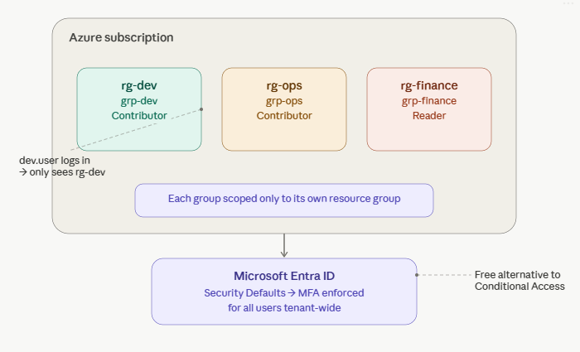

Azure Services Used
Service | Purpose
Microsoft Entra ID | Created security groups (grp-Dev, grp-Ops, grp-Finance) and test users, then assigned users to their respective groups
RBAC (Role-Based Access Control) | Assigned Contributor role to grp-Dev and grp-Ops, and Reader role to grp-Finance, each scoped to their own resource group
Security Defaults / Conditional Access | Enabled Security Defaults to enforce MFA for all users tenant-wide, Conditional Access requires P1/P2, while Security Defaults is the free alternative with less granularity
Resource Groups | Created rg-Dev, rg-Ops, and rg-Finance to logically separate and scope access for each team

Key Concepts Demonstrated
- Principle of least privilege
- Group-based RBAC
- MFA enforcement

Step-by-Step Summary
A high-level overview of what I did — not a full tutorial, just enough context to follow the screenshots.
- Created 9 users (3 for each department)
- Created three Entra ID security groups and assigned users to groups
- Created three resource groups: rg-Dev, rg-Ops, rg-Finance
- Assigned RBAC roles (Contributor for rg-Dev and rg-Ops/ Reader for rg-Finance) scoped to each resource group
- Verified access boundaries by logging in as a test user in a private browser session
- Enabled Security Defaults to enforce MFA for all users tenant-wide

Screenshots

1. Created 9 Users in Entra ID
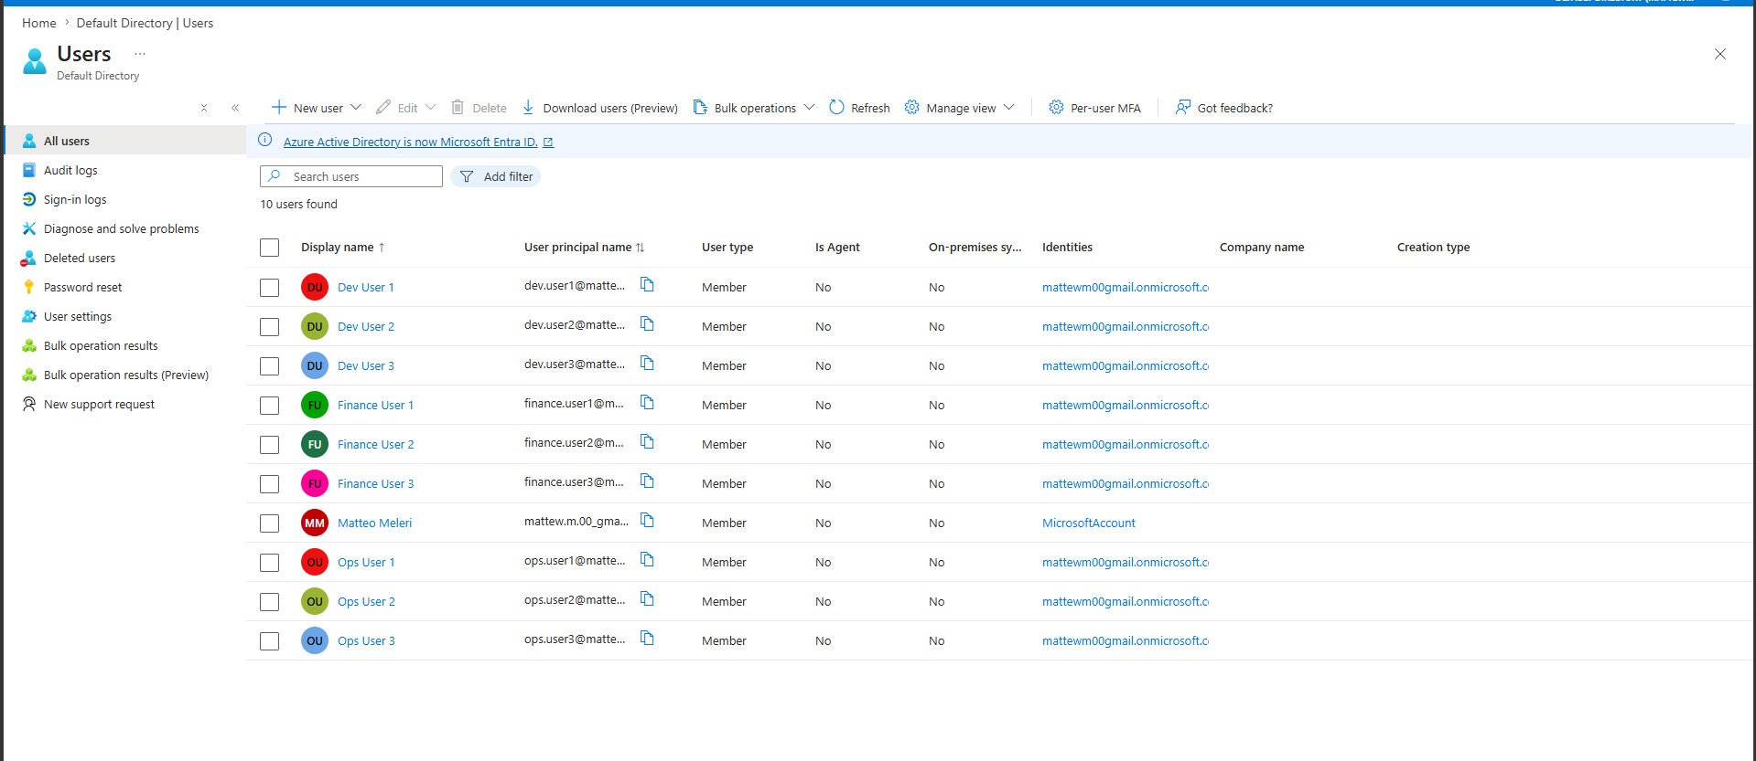
Created 9 users, 3 for each group

2. Three Groups Created
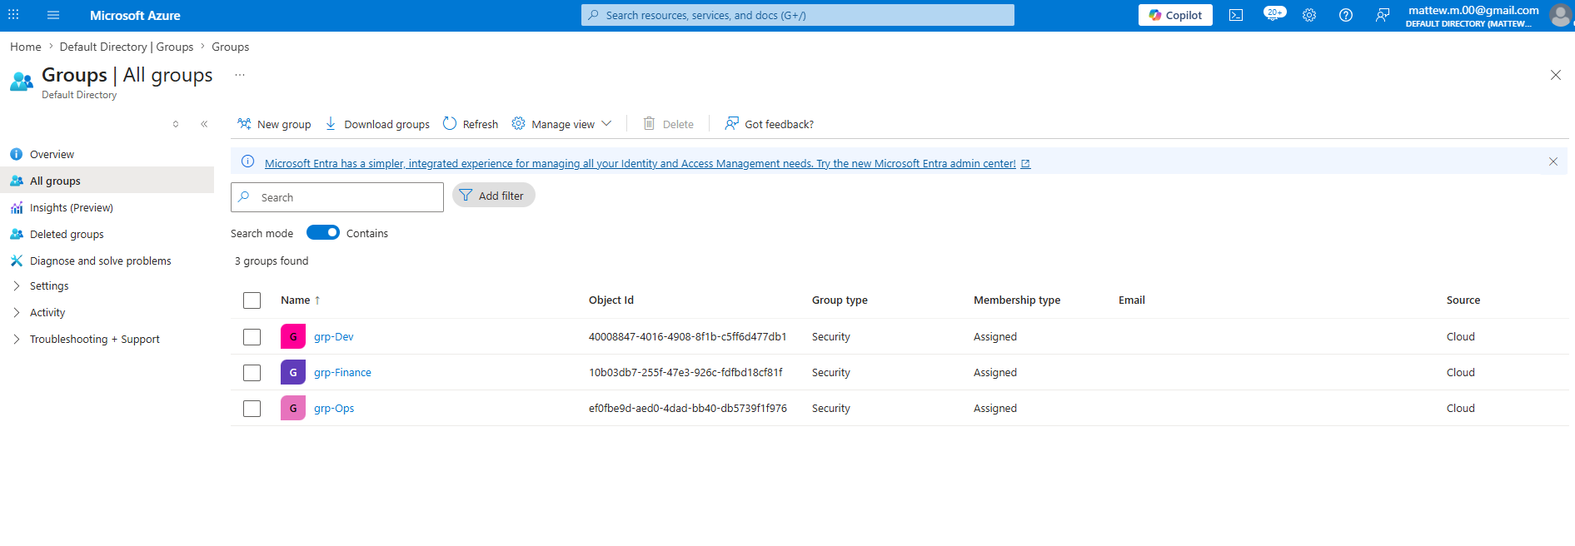
Created three groups (grp-Dev, grp-Ops, grp-Finance) each containing three users

3. Resource Groups Created
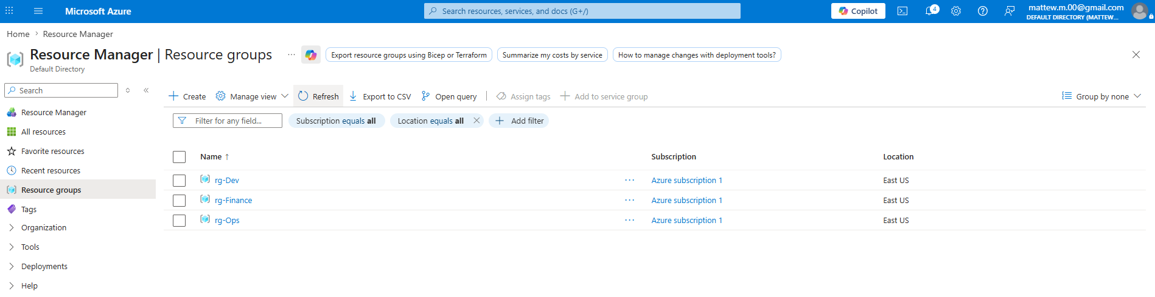
Resource groups created (rg-Dev, rg-Ops, rg-Finance)

4. Assigned each group to its corresponding Resource group
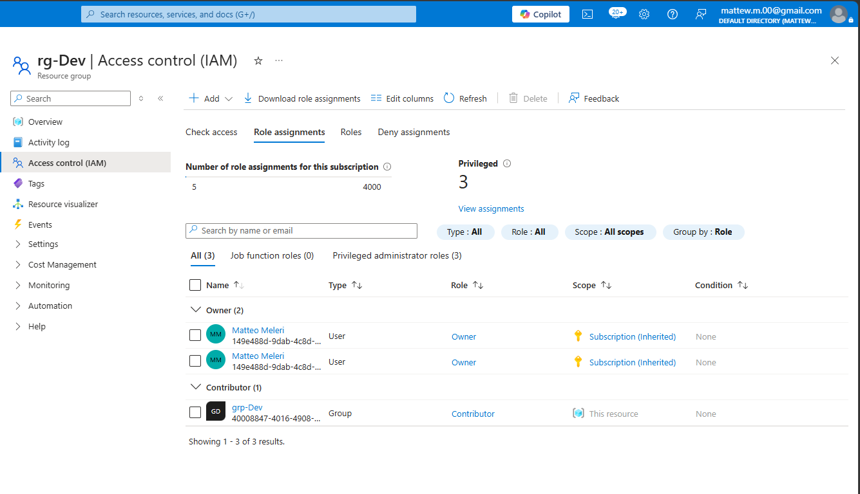Assigned grp-Dev group with contributor role to Resource Group rg-Dev

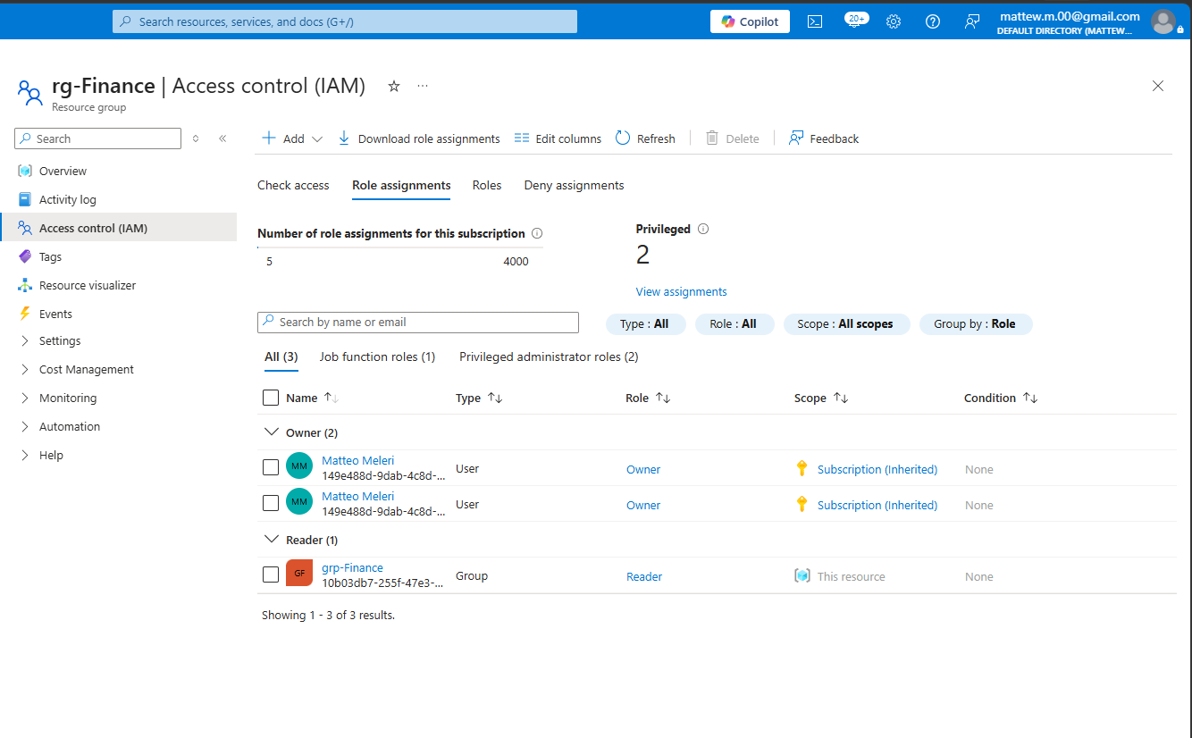
Assigned group grp-Finance with Reader role to Resource Group rg-Finance
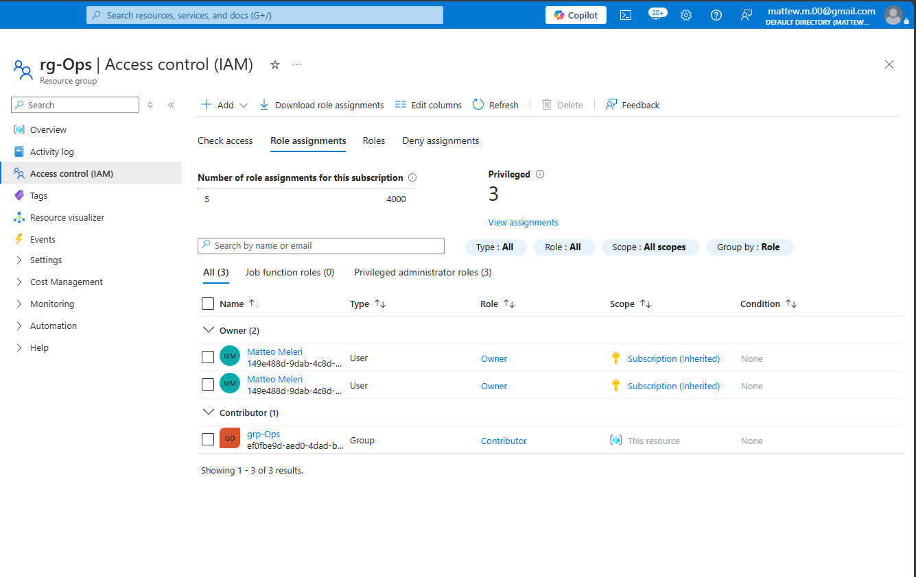
Assigned group grp-Ops with Contributor role to Resource Group rg-Ops

4. Logged in with user from Dev Group to verify role inheritance
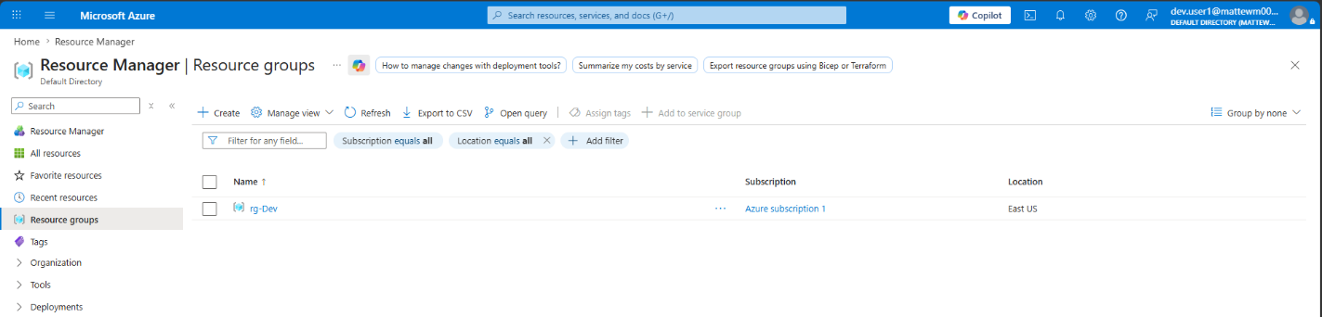
Logged in as user from the grp-Dev group to verify role inheritance, after logging in as dev.user1 only rg-Dev is visible meaning the role inheritance was successful.

5. User from Dev Group cannot access other Resource Groups

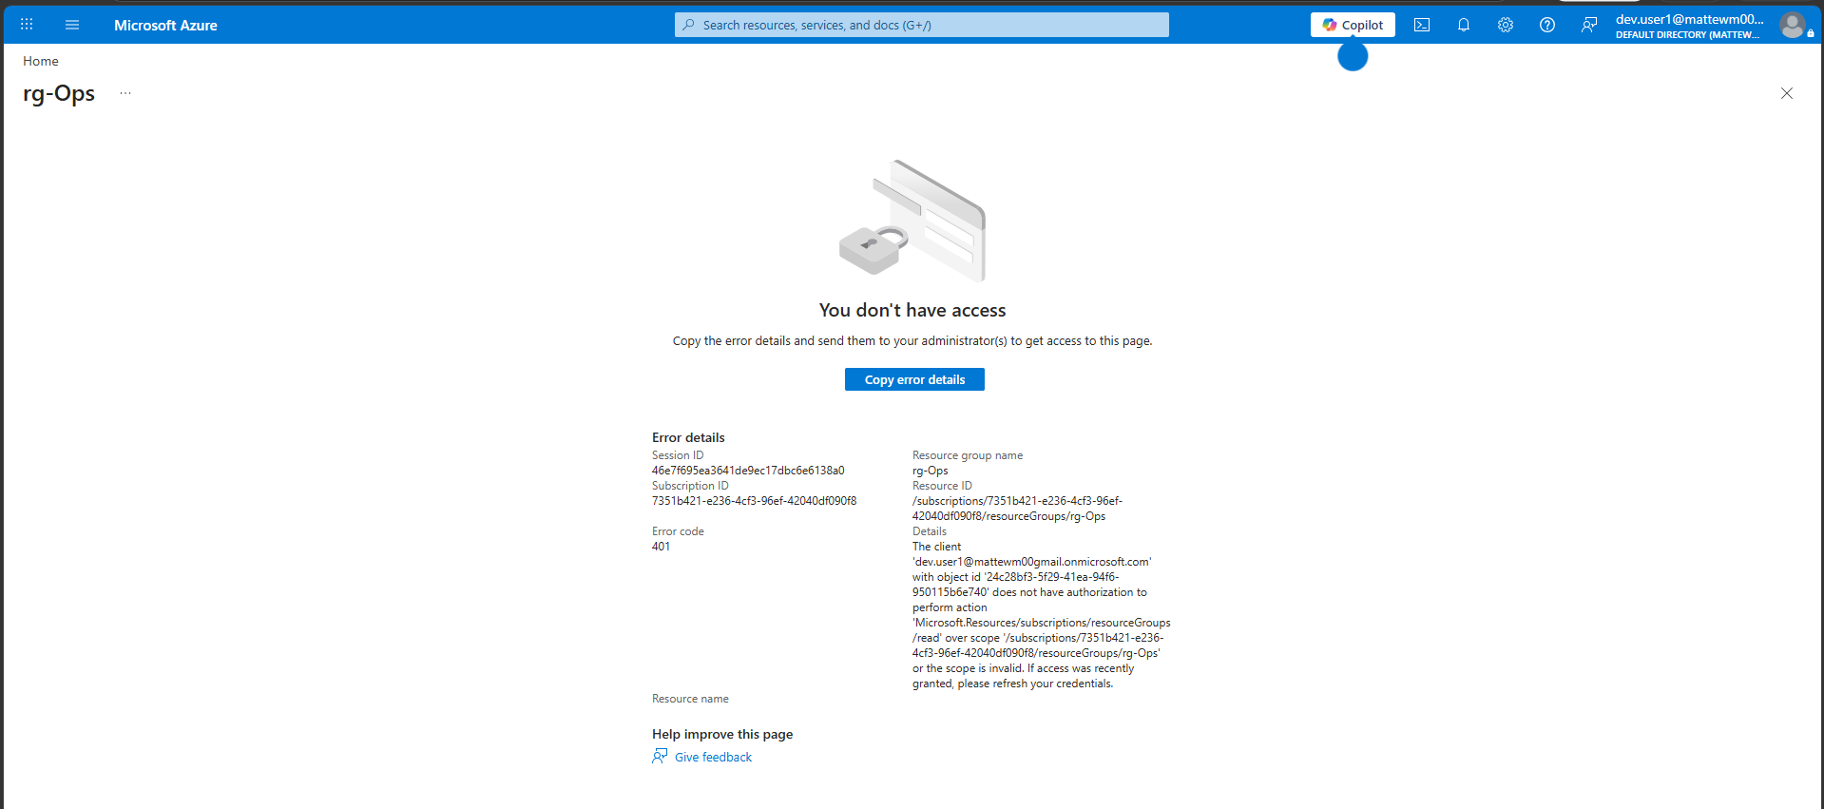

Logged in as user from the grp-Dev group it shows that I have no access to other resource groups proving once again successful role inheritance from the Resource group.

6. Enabled Security defaults

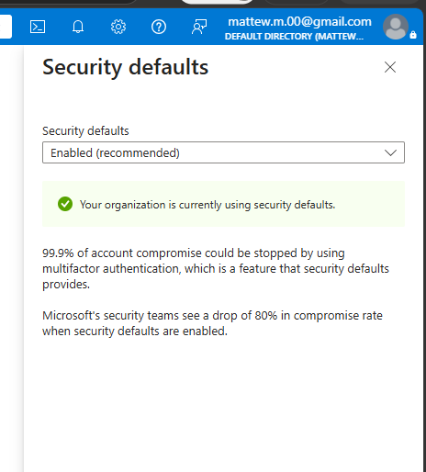

Security defaults enforces multifactor authentication tenant wide

7. Logged in as finance.user1 to check enforcement of multifactor authentication

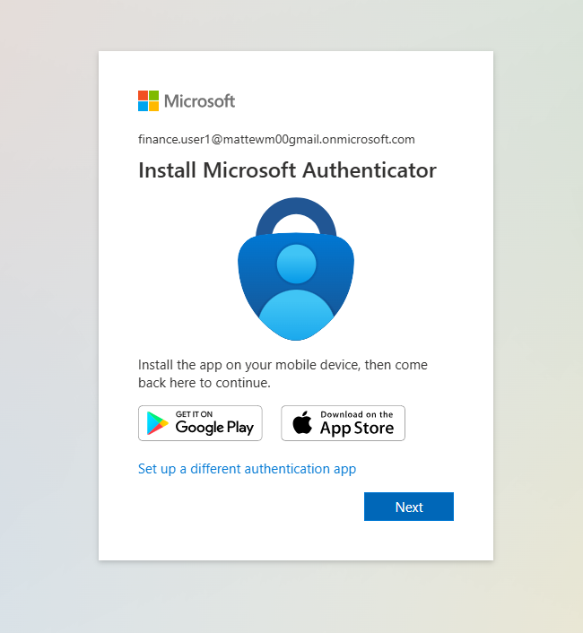

Originally planned to use Conditional Access for more granular multifactor authentication and location policy but P1/P2 license was required. Decided to opt for Security Defaults which enforced multifactor authentication for free.

What Broke and How I Fixed It

Problem 1: License Issue

Originally planned to use Conditional Access to set a location policy which would restrict logging to the US only. Unfortunately, a P1/P2 license was required and decided to use Security Defaults which enforces multifactor authentication for free, but unfortunately doesn’t allow for custom rules to be implemented.

What I Learned

This project gave me a deep understanding of how roles are inherited from Resource groups, and how groups and Resource groups can be used to manage users in a very granular way. Also, I’ve learned the practical difference between Entra ID Premium-only features and free alternatives like Security Defaults.

Cost
Resource | Approximate Cost
Entra ID, RBAC, Security Defaults | Free
Total for this lab | $0.00

Resources and References
- Microsoft Learn
- AZ-104 Study Guide — Identity and Governance section

Part of my AZ-104 Azure Administrator lab project series — 7 hands-on projects covering every exam domain.

